**Excerpt 1** *In this excerpt, Mann offers an overview of the Columbian Exchange with examples.*

“…Colon [Columbus] and his crew did not voyage alone. They were accompanied by a menagerie of insects, plants, mammals, and microorganisms. Beginning with La Isabela [Colon’s first settlement], European expeditions brought cattle, sheep, and horses, along with crops like sugar cane (originally from New Guinea), wheat (from the Middle East), bananas (from Africa), and coffee (also from Africa). Equally important, creatures the colonists knew nothing about hitchhiked along for the ride. Earthworms, mosquitoes, and cockroaches; honeybees, dandelions, and African grasses; rats of every description — all of them poured from the hulls of Colon’s vessels and those that followed, rushing like eager tourists into lands that had never seen their like before.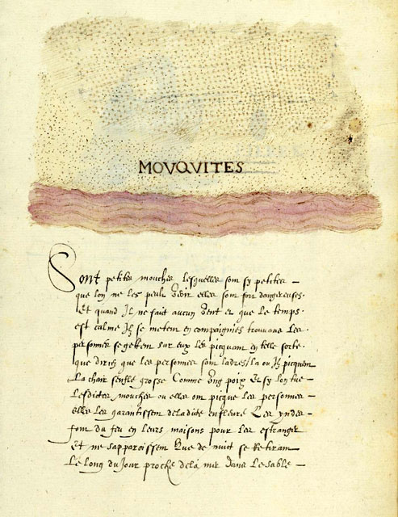

Cattle and sheep ground the American vegetation between their flat teeth, preventing the regrowth of native shrubs and trees. Beneath their hooves would sprout grasses from Africa, possibly introduced from slave ship bedding; splay-leaved [with wide leaves] and dense on the ground, they choked out native vegetation. (Alien grasses could withstand grazing better than Caribbean groundcover plants because grasses grow from the base of the leaf, unlike most other species, which grows from the tip. Grazing consumes the growth zones of the latter but has little impact on those in the former.) Over the years forests of Caribbean palm, mahogany, and ceiba [the silk-cotton tree] became forest of Australian acacia [small tree of the mimosa family], Ethiopian shrubs, and the Central American logwood. Scurrying below, mongooses from India eagerly drove Dominican snakes toward extinction. The changes continue to this day. Orange groves, introduced to Hispaniola from Spain, have recently begun to fall to the depredation of lime swallowtail butterflies, a citrus pest from Southeast Asia that probably came over in 2004. Today Hispaniola has only small fragments of its original forest.”

**1. Why do you believe Columbus brought cattle, sheep or horses with him?**

**2. What would the Taino culture have been like without cattle or horses?**

**3. What is the thesis statement of paragraph 1? How does Mann develop that thesis? Cite evidence from the text.**

**4. How did the introduction of cattle and sheep affect plant life on Hispaniola?**

**5. Why is it important that alien grasses, trees, and other plants choked out native vegetation in Hispaniola?**

**6. What can be the effect of introducing a new predator into an environment, such as the Indian mongoose in Hispaniola? Give an example.**

**7. How does Mann show that the Columbian Exchange is still ongoing?**

**8. In the second paragraph of this excerpt, Mann implies his thesis but does not actually state it. What is the implied thesis of paragraph 2? How does he imply the thesis?**

**Excerpt 2**  
*Here Mann gives a specific example of unintended consequences.*

Natives and newcomers interacted in unexpected ways, creating biological bedlam. When Spanish colonists imported African plantains [a tropical plant that resembles a banana] in 1516, the Harvard entomologist Edward O. Wilson has proposed, they also imported scale insects, small creatures with tough, waxy coats that suck the juices from plant roots and stems. About a dozen banana-infesting scale insects are known in Africa. In Hispaniola, Wilson argued, these insects had no natural enemies. In consequence, their numbers must have exploded — a phenomenon known to science as “ecological release.” This spread of scale insects would have dismayed the island’s European banana farmers but delighted one of its native species: the tropical fire ant *Solenopsis geminata*. *S. geminata* is fond of dining on scale insects’ sugary excrement; to ensure the flow, the ants will attack anything that disturbs them. A big increase in scale insects would have led to a big increase in fire ants.

So far this is informed speculation. What happened in 1518 and 1519 is not. In those years, according to Bartolome de Las Casas, a missionary priest who lived through the incident, Spanish orange, pomegranate, and cassia plantations were destroyed “from the roots up.” Thousands of acres of orchards were “all scorched and dried out, as though flames had fallen from the sky and burned them.” The actual culprit, Wilson argued, was the sap-sucking scale insects. But what the Spaniards *saw* was *S. geminata* — “an infinite number of ants,” Las Casas reported, their stings causing “greater pains than wasps that bite and hurt men.” The hordes of ants swarmed through houses, blackening roofs “as if they had been sprayed with charcoal dust,” covering floors in such numbers that colonists could sleep only by placing the legs of their beds in bowls of water. They “could not be stopped in any way nor by any human means.”… Overwhelmed and terrified, Spaniards abandoned their homes to the insects….

**9. According to the author and his sources, what unintended import came in to Hispaniola with plantains?**

**10. How does the author define scale insects?**

**11. Define “ecological release.”**

**12. Using the example of scale insects as evidence, why are natural predators important to an ecosystem?**

**13. What was the unintended effect of this import, scale insects, according to Wilson? Why did they have this effect?**

**14. Mann begins the second paragraph in this excerpt with “So far this is informed speculation.” What effect does this admission have on our perception of Mann as an author?**

**15. What document from the 1500s seems to confirm this unintended effect?**

**16. What was the unintended effect to settlers of the introduction of plantains to Hispaniola?**

**17. How does Mann combine 16th and 20th century evidence?**

**Excerpt 3** *Mann explains the most “dramatic impact of the Columbian Exchange.”*

From the human perspective, the most dramatic impact of the Columbian Exchange was on humankind itself. Spanish accounts suggest that Hispaniola had a large native population: Colón, for instance, casually described the Taino as “innumerable, for I believe there to be millions upon millions of them.” Las Casas claimed the population to be “more than three million.” Modern researchers have not nailed down the number; estimates range from 60,000 to almost 8,000,000. A careful study in 2003 argued that the true figure was “a few hundred thousand.” No matter what the original number, though, the European impact was horrific. In 1514, twenty-two years after Colon’s first voyage, the Spanish government counted up the Indians on Hispaniola for the purpose of allocating them among colonists as laborers. Census agents fanned the across the island but found only 26,000 Taino. Thirty-four years later, according to one scholarly Spanish resident, fewer than 500 Taino were alive….

Spanish cruelty played its part in the calamity, but its larger cause was the Columbian Exchange. Before Colon none of the epidemic diseases common in Europe and Asia existed in the Americas. The viruses that cause smallpox, influenza, hepatitis, measles, encephalitis, and viral pneumonia; the bacteria that cause tuberculosis, diphtheria, cholera, typhus, scarlet fever, and bacterial meningitis — by a quirk of evolutionary history, all were unknown in the Western Hemisphere. Shipped across the ocean from Europe these maladies consumed Hispaniola’s native population with stunning rapacity. The first recorded epidemic, perhaps due to swine flu, was in 1493….

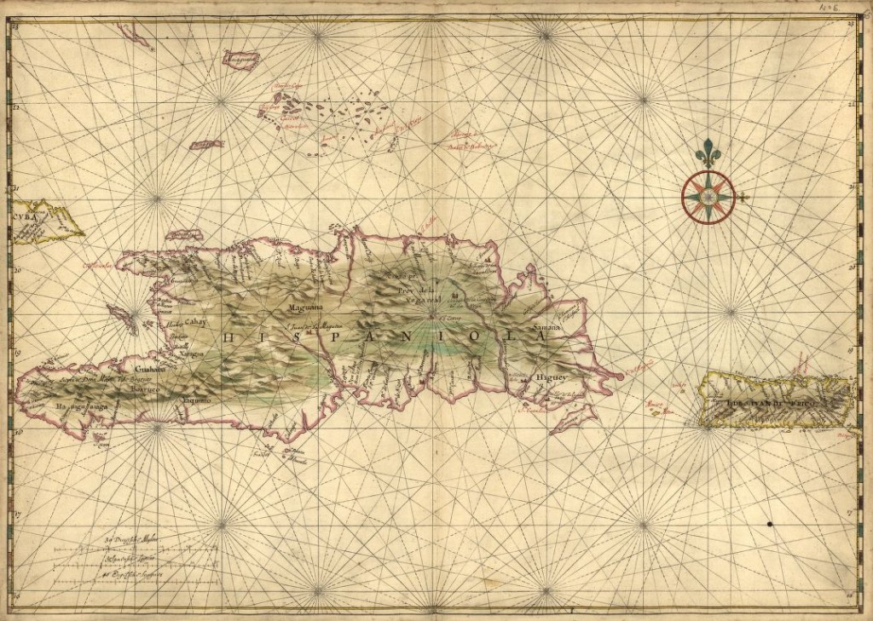

*Joan Vinckeboons, “Map of the islands of Hispaniola and Puerto Rico,” 1639(?)*

**18. What is the thesis of this excerpt?**

**19. What evidence does Mann use to develop this thesis?**

**20. Why did the Spanish conduct a census of the Indians on Hispaniola in 1514? What did the census find regarding the Taino population?**

**21. According to the author, what two factors caused this change in population? Which cause was the most influential?**

**22. The third sentence in paragraph 2 of this excerpt uses a rhetorical device called asyndeton. Asyndeton is a list of items with conjunctions omitted and can be used to imply that there are more items that could be added to the list. What types of items does the author list using asyndeton? What is the effect?**

**23. Why was the introduction of these diseases so devastating for the Taino and not the Spanish explorers?**

**24. What is the effect of Mann including the information about the first recorded epidemic, which occurred within one year of Columbus’s arrival?**